Exercise 1:
Main.java
package com.library;

import com.library.service.BookService;
import org.springframework.context.ApplicationContext;
import org.springframework.context.support.ClassPathXmlApplicationContext;

public class Main {

public static void main(String[] args) {

ApplicationContext context =
new ClassPathXmlApplicationContext("applicationContext.xml");

BookService service = context.getBean("bookService", BookService.class);

service.showService();
}
}
applicationContext.xml
<?xml version="1.0" encoding="UTF-8"?>

<beans xmlns="http://www.springframework.org/schema/beans"
xmlns:xsi="http://www.w3.org/2001/XMLSchema-instance"
xsi:schemaLocation="
http://www.springframework.org/schema/beans
https://www.springframework.org/schema/beans/spring-beans.xsd">

<bean id="bookRepository"
class="com.library.repository.BookRepository"/>

<bean id="bookService"
class="com.library.service.BookService">

<property name="bookRepository" ref="bookRepository"/>

</bean>

</beans>

BookRepository.java
package com.library.repository;

public class BookRepository {

public void display() {
System.out.println("Book Repository Working");
}
}
BookService.java
package com.library.service;

import com.library.repository.BookRepository;

public class BookService {

private BookRepository bookRepository;

public void setBookRepository(BookRepository bookRepository) {
this.bookRepository = bookRepository;
}

public void showService() {
System.out.println("Book Service Working");
bookRepository.display();
}
}

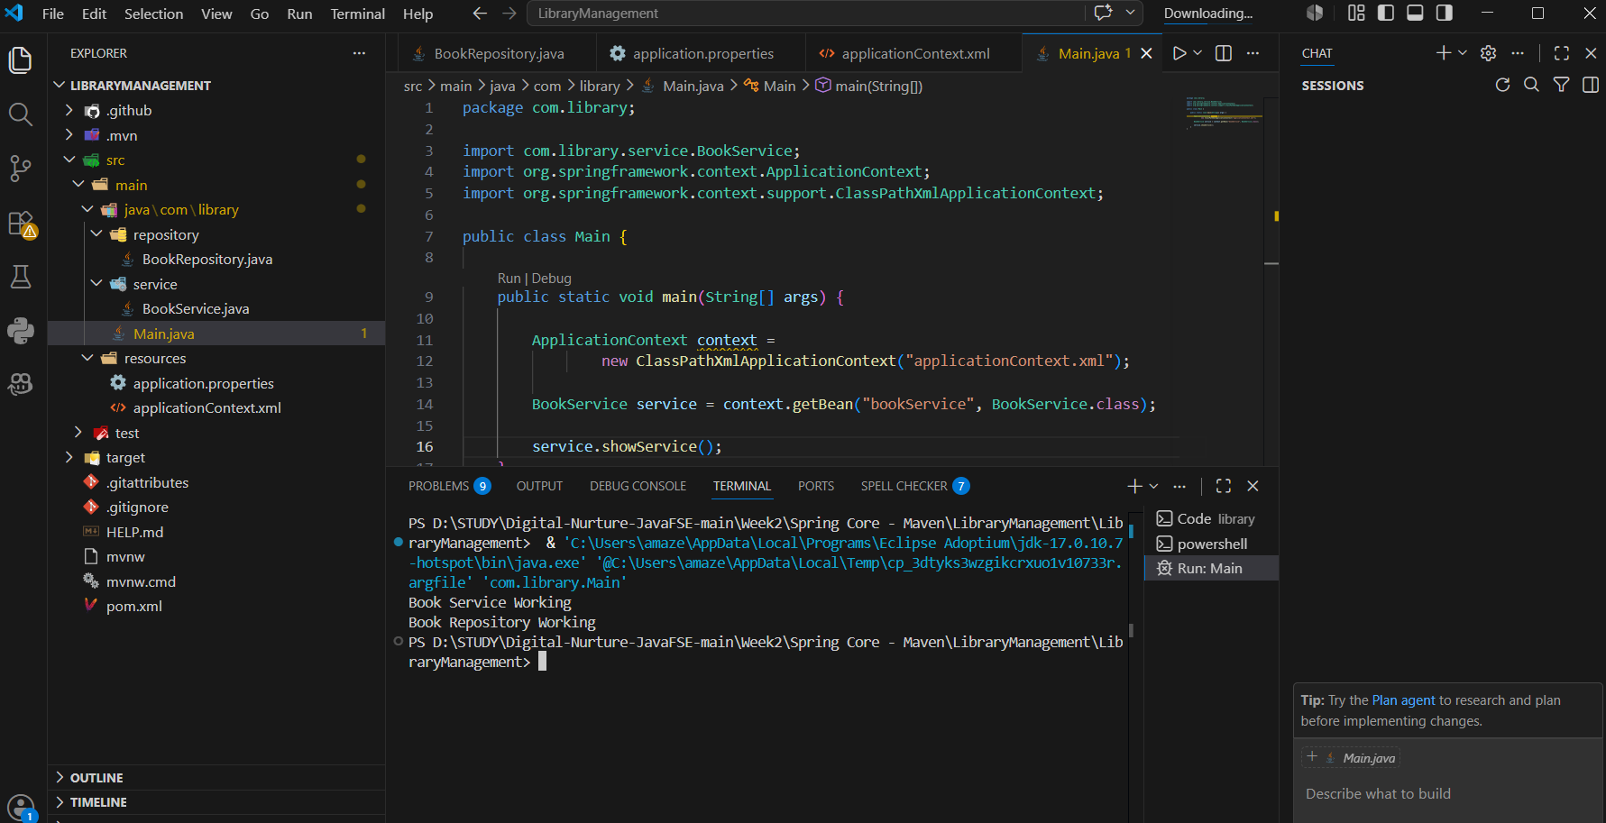

Exercise 2:
Main.java
package com.library;

import com.library.service.BookService;
import org.springframework.context.ApplicationContext;
import org.springframework.context.support.ClassPathXmlApplicationContext;

public class Main {

public static void main(String[] args) {

ApplicationContext context =
new ClassPathXmlApplicationContext("applicationContext.xml");

BookService service = context.getBean("bookService", BookService.class);

service.showService();
}
}
BookService.java
package com.library.service;

import com.library.repository.BookRepository;

public class BookService {

private BookRepository bookRepository;

public void setBookRepository(BookRepository bookRepository) {
this.bookRepository = bookRepository;
}

public void showService() {
System.out.println("Book Service Working");
bookRepository.display();
}
}
BookRepository.java
package com.library.repository;

public class BookRepository {

public void display() {
System.out.println("Book Repository Working");
}
}
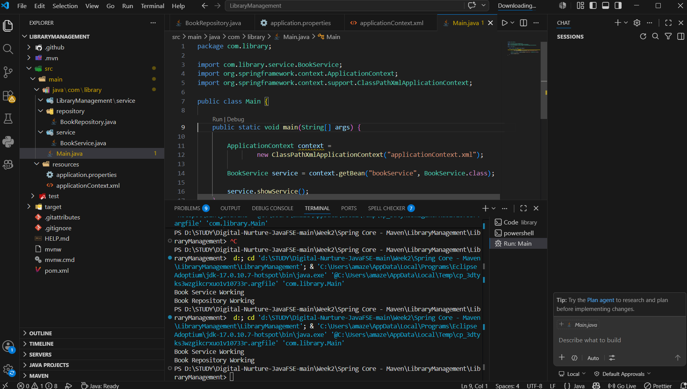

Exercise 3:
LoggingAspect.java
package com.library.aspect;

import org.aspectj.lang.ProceedingJoinPoint;
import org.aspectj.lang.annotation.Around;
import org.aspectj.lang.annotation.Aspect;

@Aspect
public class LoggingAspect {

@Around("execution(* com.library.service.*.*(..))")
public Object logExecutionTime(ProceedingJoinPoint jp) throws Throwable {

long s = System.currentTimeMillis();

Object o = jp.proceed();

long e = System.currentTimeMillis();

System.out.println(jp.getSignature().getName()
+ " executed in " + (e - s) + " ms");

return o;
}
}
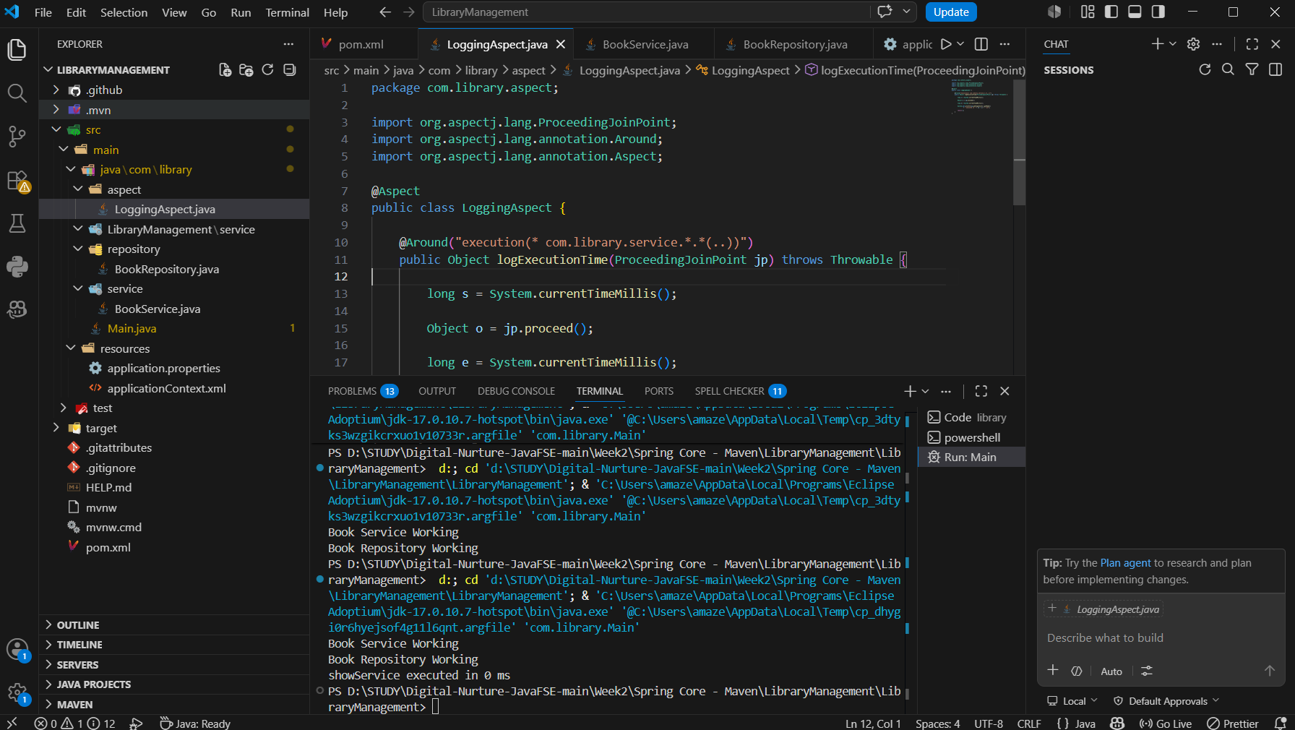

Exercise 4:
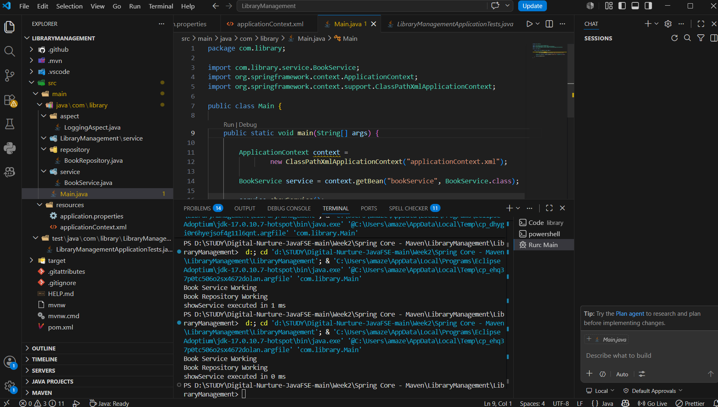

Exercise 5:
Main.java
package com.library;

import com.library.service.BookService;
import org.springframework.context.ApplicationContext;
import org.springframework.context.support.ClassPathXmlApplicationContext;

public class Main {

public static void main(String[] args) {

ApplicationContext context =
new ClassPathXmlApplicationContext("applicationContext.xml");

BookService service =
context.getBean("bookService", BookService.class);

service.showService();
}

}

BookService.java
package com.library.service;

import com.library.repository.BookRepository;

public class BookService {

private BookRepository bookRepository;

public void setBookRepository(BookRepository bookRepository) {
this.bookRepository = bookRepository;
}

public void showService() {
System.out.println("Book Service Working");
bookRepository.display();
}

}
BookRepository.java
package com.library.repository;

public class BookRepository {

public void display() {
System.out.println("Book Repository Working");
}

}
applicationContext.xml
<?xml version="1.0" encoding="UTF-8"?>

<beans xmlns="http://www.springframework.org/schema/beans"
xmlns:xsi="http://www.w3.org/2001/XMLSchema-instance"
xsi:schemaLocation="
http://www.springframework.org/schema/beans
https://www.springframework.org/schema/beans/spring-beans.xsd">

<bean id="bookRepository"
class="com.library.repository.BookRepository"/>

<bean id="bookService"
class="com.library.service.BookService">

<property name="bookRepository" ref="bookRepository"/>

</bean>

</beans>
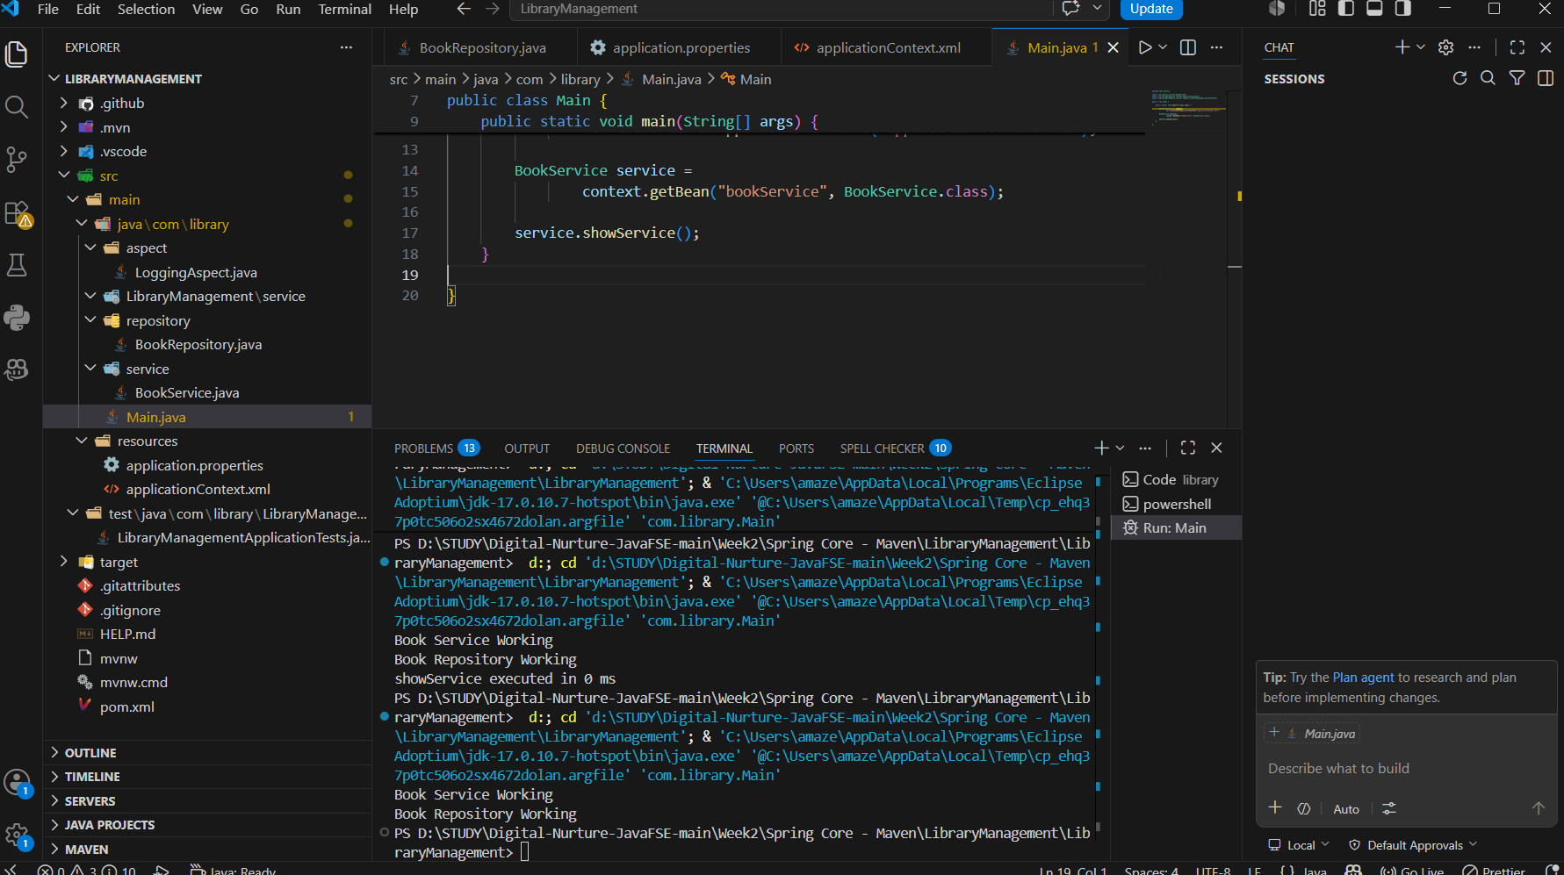

Exercise 6:
Main.java
package com.library;

import com.library.service.BookService;
import org.springframework.context.ApplicationContext;
import org.springframework.context.support.ClassPathXmlApplicationContext;

public class Main {

public static void main(String[] args) {

ApplicationContext context =
new ClassPathXmlApplicationContext("applicationContext.xml");

BookService service =
context.getBean(BookService.class);

service.showService();

}

}
BookService.java
package com.library.service;

import com.library.repository.BookRepository;
import org.springframework.beans.factory.annotation.Autowired;
import org.springframework.stereotype.Service;

@Service
public class BookService {

private BookRepository bookRepository;

@Autowired
public void setBookRepository(BookRepository bookRepository) {
this.bookRepository = bookRepository;
}

public void showService() {
System.out.println("Book Service Working");
bookRepository.display();
}

}

BookRepository.java
package com.library.repository;

import org.springframework.stereotype.Repository;

@Repository
public class BookRepository {

public void display() {
System.out.println("Book Repository Working");
}

}
applicationContext.xml
<?xml version="1.0" encoding="UTF-8"?>

<beans xmlns="http://www.springframework.org/schema/beans"
xmlns:xsi="http://www.w3.org/2001/XMLSchema-instance"
xmlns:context="http://www.springframework.org/schema/context"
xsi:schemaLocation="
http://www.springframework.org/schema/beans
https://www.springframework.org/schema/beans/spring-beans.xsd
http://www.springframework.org/schema/context
https://www.springframework.org/schema/context/spring-context.xsd">

<context:component-scan base-package="com.library"/>

</beans>
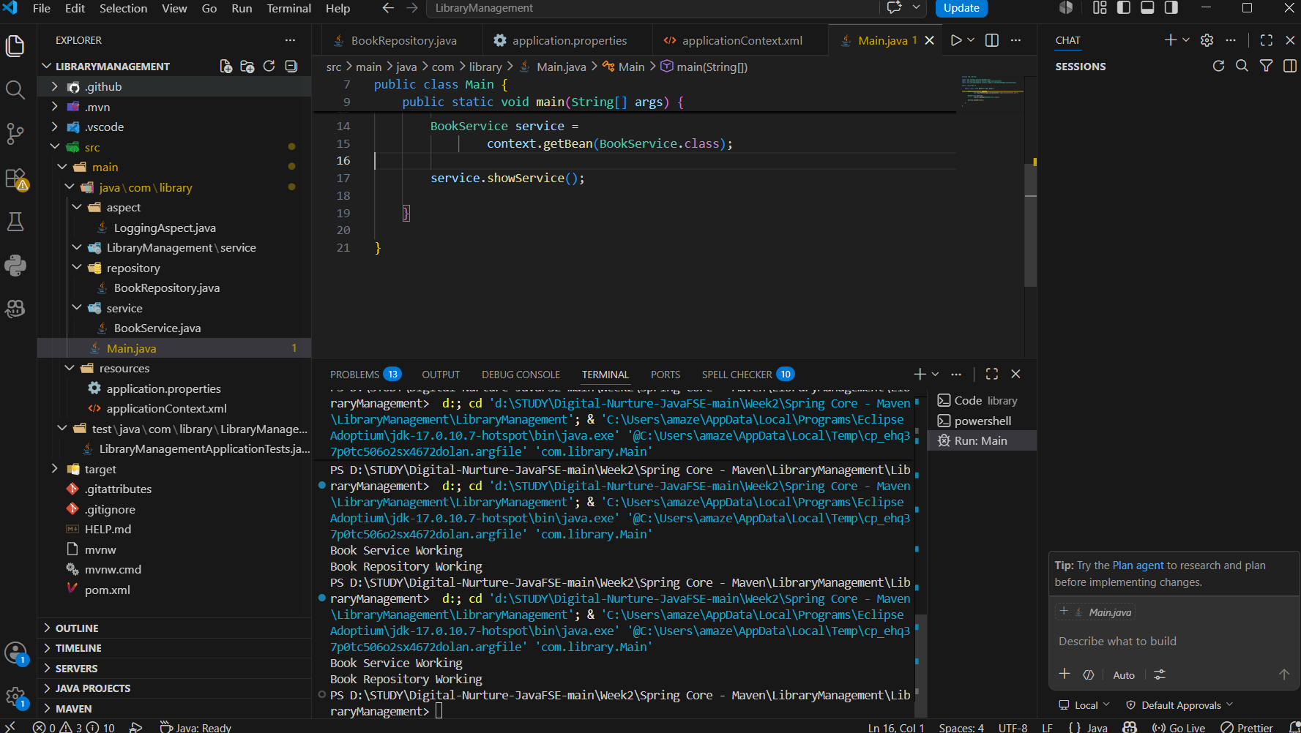

Exercise 7:
applicationContext.xml
<?xml version="1.0" encoding="UTF-8"?>

<beans xmlns="http://www.springframework.org/schema/beans"
xmlns:xsi="http://www.w3.org/2001/XMLSchema-instance"
xsi:schemaLocation="
http://www.springframework.org/schema/beans
https://www.springframework.org/schema/beans/spring-beans.xsd">

<bean id="bookRepository"
class="com.library.repository.BookRepository"/>

<bean id="bookService"
class="com.library.service.BookService">

<constructor-arg ref="bookRepository"/>

<property name="bookRepository"
ref="bookRepository"/>

</bean>

</beans>

BookService.java
package com.library.service;

import com.library.repository.BookRepository;

public class BookService {

private BookRepository bookRepository;

public BookService(BookRepository bookRepository) {
this.bookRepository = bookRepository;
System.out.println("Constructor Injection");
}

public void setBookRepository(BookRepository bookRepository) {
this.bookRepository = bookRepository;
System.out.println("Setter Injection");
}

public void showService() {
System.out.println("Book Service Working");
bookRepository.display();
}
}
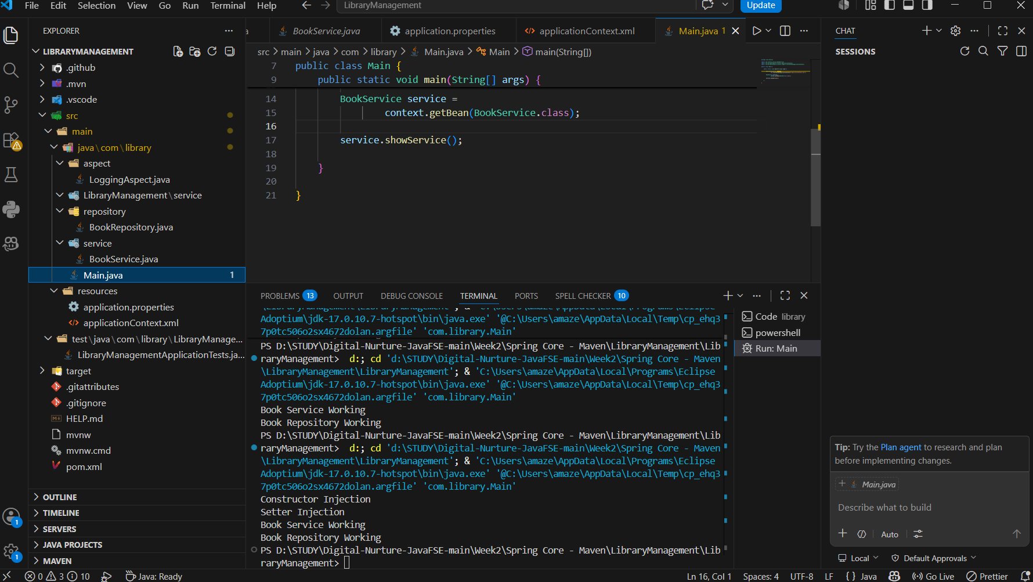

Exercise 8:
LoggingAspect.java
package com.library.aspect;

import org.aspectj.lang.JoinPoint;
import org.aspectj.lang.annotation.After;
import org.aspectj.lang.annotation.Aspect;
import org.aspectj.lang.annotation.Before;

@Aspect
public class LoggingAspect {

@Before("execution(* com.library.service.*.*(..))")
public void before(JoinPoint jp) {
System.out.println("Before executing: " + jp.getSignature().getName());
}

@After("execution(* com.library.service.*.*(..))")
public void after(JoinPoint jp) {
System.out.println("After executing: " + jp.getSignature().getName());
}

}

applicationContext.xml
<?xml version="1.0" encoding="UTF-8"?>

<beans xmlns="http://www.springframework.org/schema/beans"
xmlns:xsi="http://www.w3.org/2001/XMLSchema-instance"
xmlns:aop="http://www.springframework.org/schema/aop"
xsi:schemaLocation="
http://www.springframework.org/schema/beans
https://www.springframework.org/schema/beans/spring-beans.xsd
http://www.springframework.org/schema/aop
https://www.springframework.org/schema/aop/spring-aop.xsd">

<bean id="bookRepository"
class="com.library.repository.BookRepository"/>

<bean id="bookService"
class="com.library.service.BookService">

<property name="bookRepository"
ref="bookRepository"/>

</bean>

<bean id="loggingAspect"
class="com.library.aspect.LoggingAspect"/>

<aop:aspectj-autoproxy/>

</beans>

BookService.java
package com.library.service;

import com.library.repository.BookRepository;

public class BookService {

private BookRepository bookRepository;

public void setBookRepository(BookRepository bookRepository) {
this.bookRepository = bookRepository;
}

public void showService() {
System.out.println("Book Service Working");
bookRepository.display();
}

}

BookRepository.java
package com.library.repository;

public class BookRepository {

public void display() {
System.out.println("Book Repository Working");
}

}
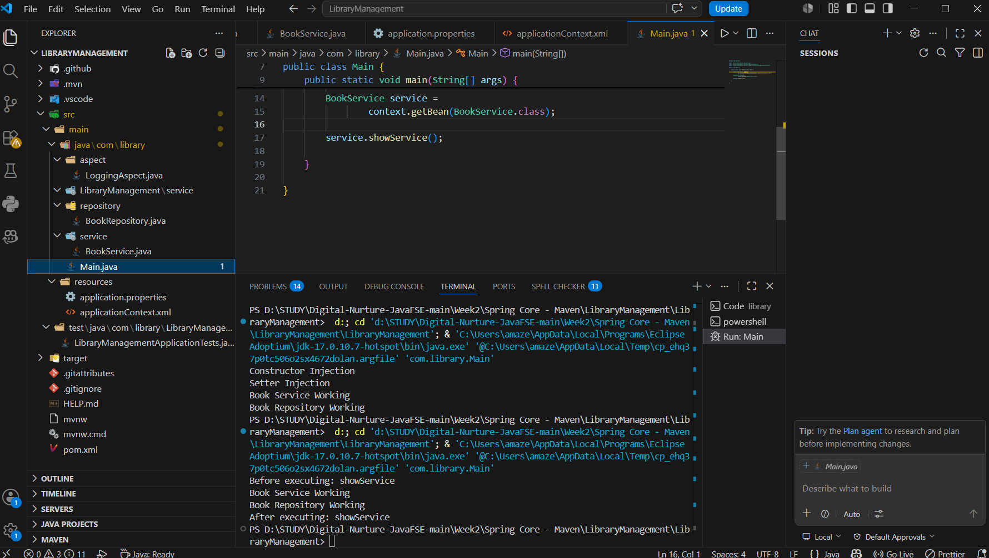

Exercise 9:
application.properties
spring.datasource.url=jdbc:h2:mem:librarydb
spring.datasource.driverClassName=org.h2.Driver
spring.datasource.username=sa
spring.datasource.password=

spring.jpa.hibernate.ddl-auto=update
spring.jpa.show-sql=true

spring.h2.console.enabled=true

Book.java
package com.library.entity;

import jakarta.persistence.Entity;
import jakarta.persistence.GeneratedValue;
import jakarta.persistence.GenerationType;
import jakarta.persistence.Id;

@Entity
public class Book {

@Id
@GeneratedValue(strategy = GenerationType.IDENTITY)
private Long id;

private String title;

private String author;

public Book() {
}

public Book(Long id, String title, String author) {
this.id = id;
this.title = title;
this.author = author;
}

public Long getId() {
return id;
}

public void setId(Long id) {
this.id = id;
}

public String getTitle() {
return title;
}

public void setTitle(String title) {
this.title = title;
}

public String getAuthor() {
return author;
}

public void setAuthor(String author) {
this.author = author;
}
}

BookRepository.java
package com.library.repository;

import com.library.entity.Book;
import org.springframework.data.jpa.repository.JpaRepository;

public interface BookRepository extends JpaRepository<Book, Long> {
}

BookController.java
package com.library.controller;

import com.library.entity.Book;
import com.library.repository.BookRepository;
import org.springframework.web.bind.annotation.*;

import java.util.List;

@RestController
@RequestMapping("/books")
public class BookController {

private final BookRepository repo;

public BookController(BookRepository repo) {
this.repo = repo;
}

@GetMapping
public List<Book> getAll() {
return repo.findAll();
}

@PostMapping
public Book add(@RequestBody Book b) {
return repo.save(b);
}

@GetMapping("/{id}")
public Book get(@PathVariable Long id) {
return repo.findById(id).orElse(null);
}

@PutMapping("/{id}")
public Book update(@PathVariable Long id, @RequestBody Book b) {
b.setId(id);
return repo.save(b);
}

@DeleteMapping("/{id}")
public void delete(@PathVariable Long id) {
repo.deleteById(id);
}
}

LibraryManagementApplication.java
package com.library;

import org.springframework.boot.SpringApplication;
import org.springframework.boot.autoconfigure.SpringBootApplication;

@SpringBootApplication
public class LibraryManagementApplication {

public static void main(String[] args) {
SpringApplication.run(LibraryManagementApplication.class, args);
}
}
